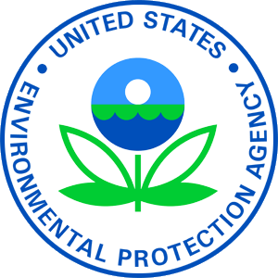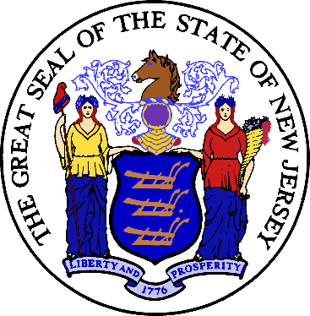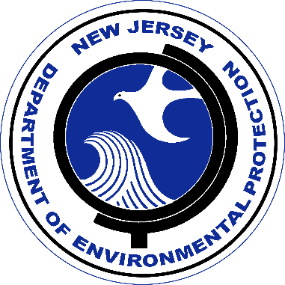

Construction of upgrades and improvements to [Hardyston, Summit Lake PFAS Removal Treatment Project (Township of Hardyston), $1,308,000.00] were financed by the New Jersey Water Bank (NJWB). The NJWB is a State Revolving Fund program jointly administered by the New Jersey Department of Environmental Protection (DEP) and the New Jersey Infrastructure Bank (NJIB) and uses a combination of funds provided by the United States Environmental Protection Agency, the DEP, and the NJIB to provide very low interest loans to borrowers for environmental infrastructure projects.

This project will provide water quality benefits [construction of a new pre-engineered metal building to equip all necessary water treatment equipment] for residents and businesses in [Township of Hardyston, County of Sussex].

State Revolving Fund programs around the nation provide states and communities the resources necessary to maintain and improve the infrastructure protecting our valuable water resources nationwide.

