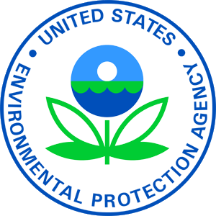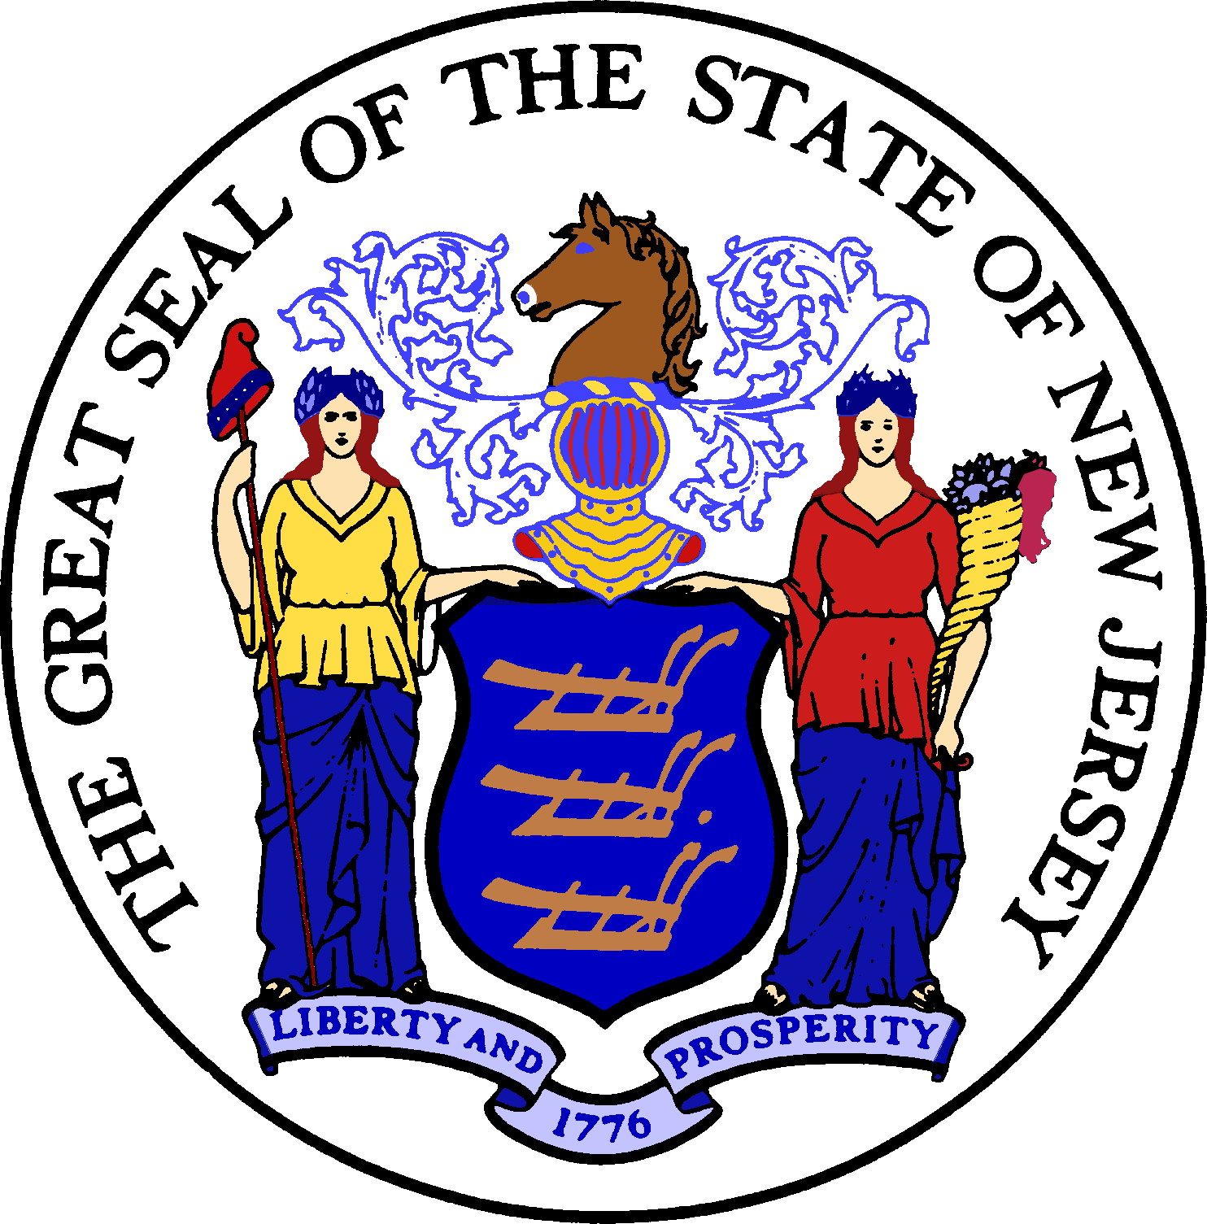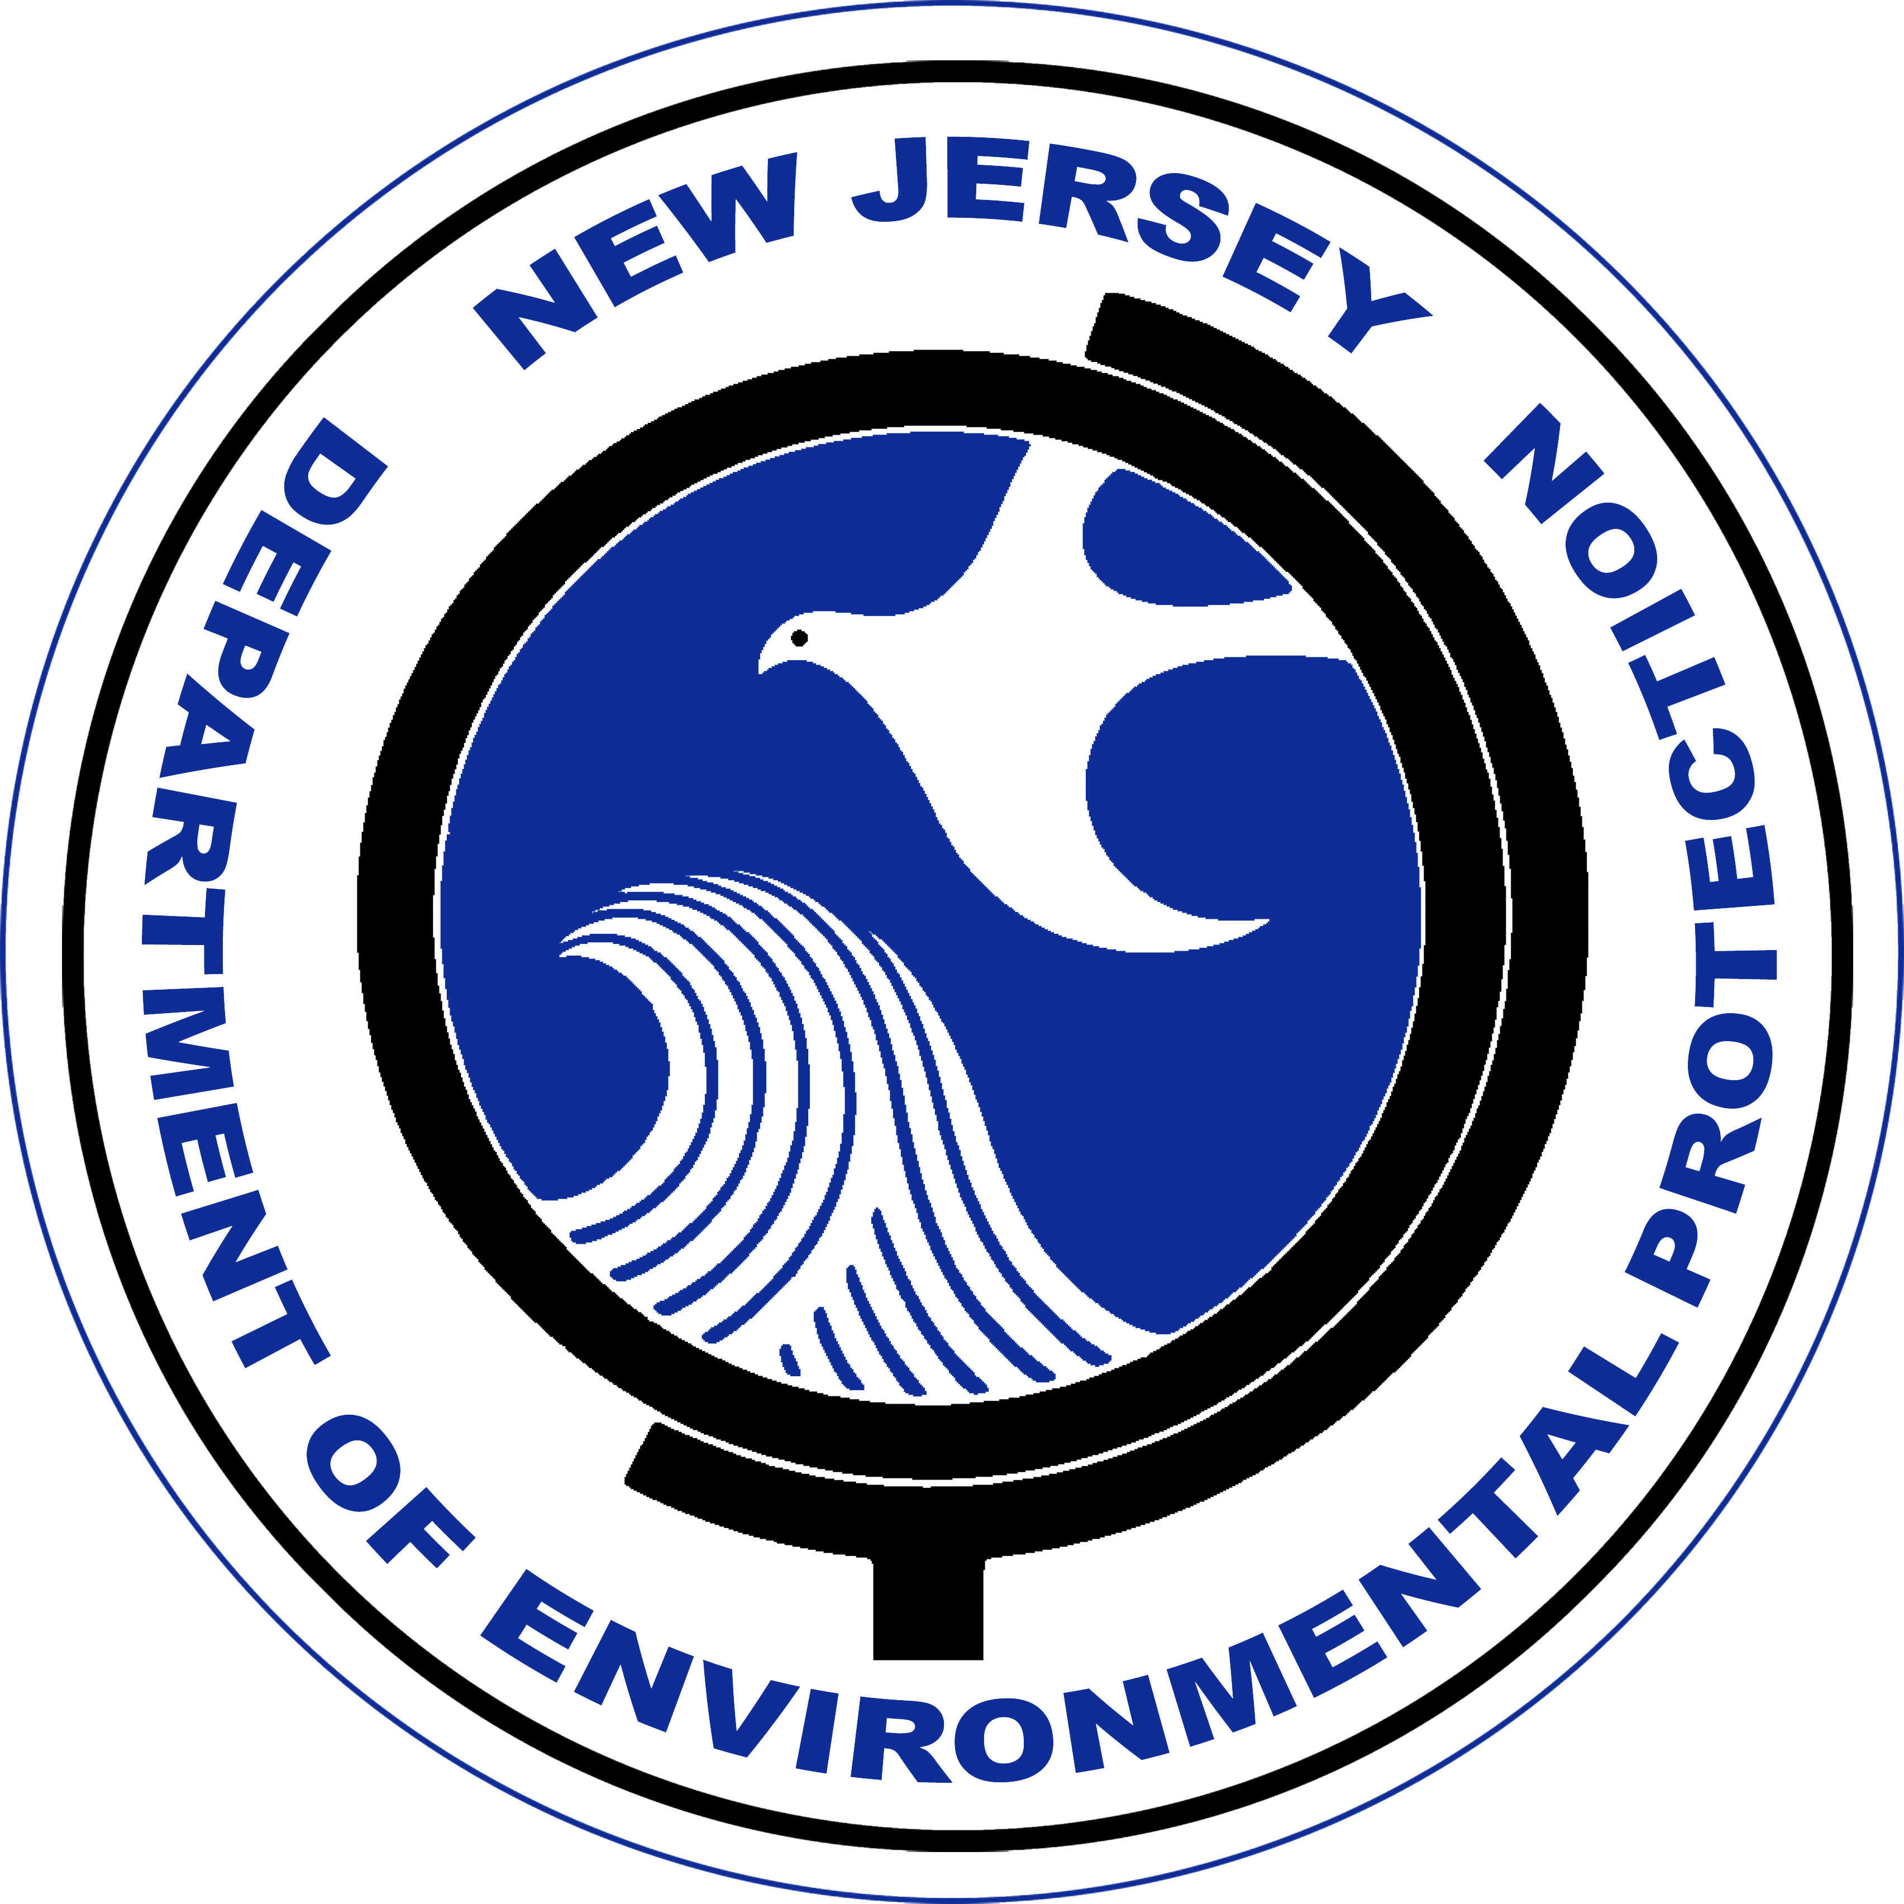

Construction of upgrades and improvements to [Hamilton Well 12C Water Treatment Plant, Hamilton Township, $3,390,000.00] were financed by the New Jersey Water Bank (NJWB). The NJWB is a State Revolving Fund program jointly administered by the New Jersey Department of Environmental Protection (DEP) and the New Jersey Infrastructure Bank (Infrastructure Bank) and uses a combination of funds provided by the United States Environmental Protection Agency, the DEP, and the Infrastructure Bank to provide very low interest loans to borrowers for environmental infrastructure projects.

This project will provide water quality benefits [The work will include but is not limited to the tasks necessary for the construction of a new building (known as the PFAS Treatment Building) at the Hamilton Well 12 facility.] for residents and businesses in [Hamilton Township, Mercer County].

State Revolving Fund programs around the nation provide states and communities the resources necessary to maintain and improve the infrastructure protecting our valuable water resources nationwide.

